Q1.
Answer is D.

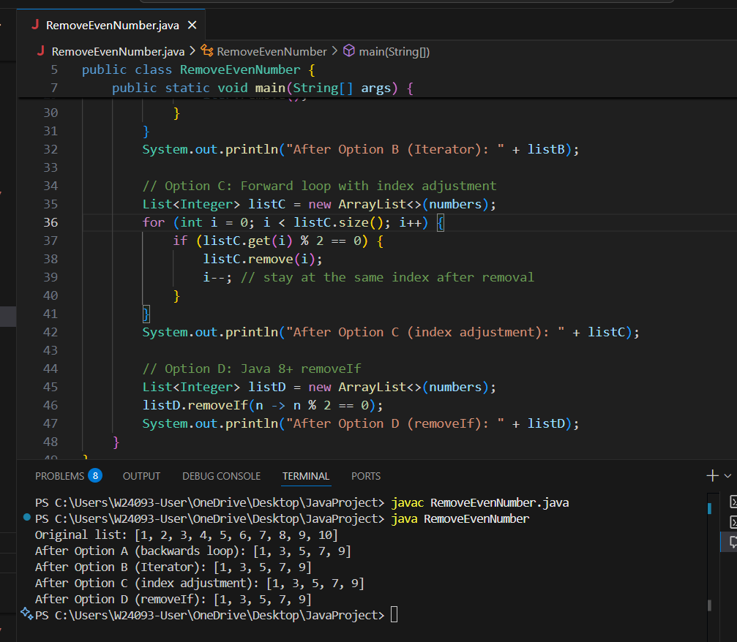

A: Loop backwards to avoid skipping elements after removal.

B: Use Iterator’s remove() to safely delete elements.

C: Forward loop with i-- to re-check the shifted element.

D: Use Java 8+ removeIf for concise and readable code.

Q2.
Answer is A.

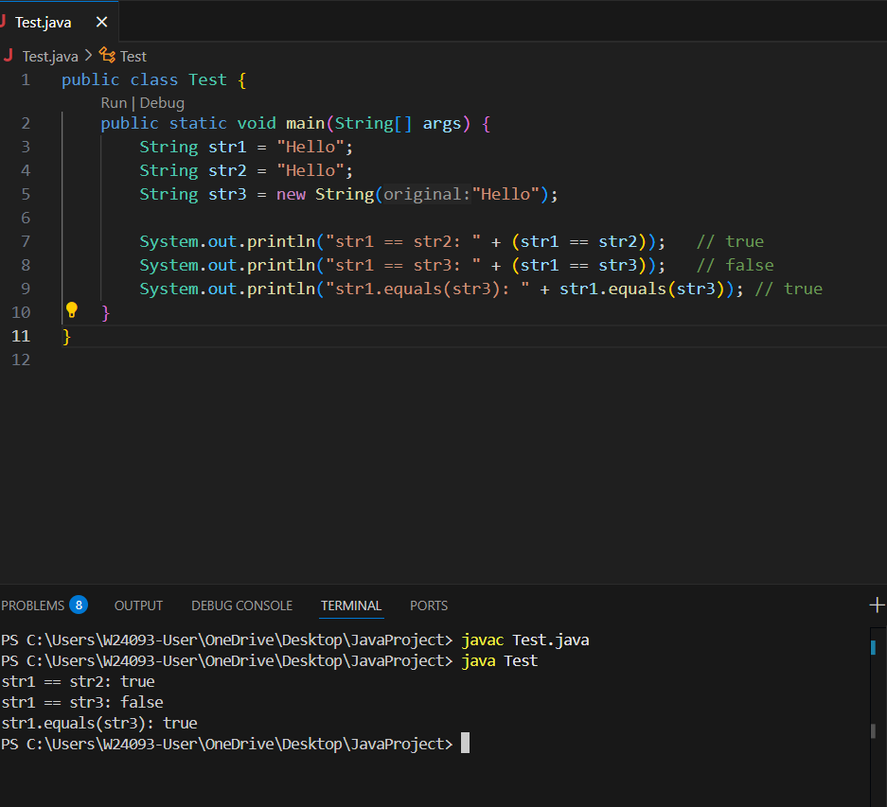

- true, false, true.

Q3.
Answer is C.

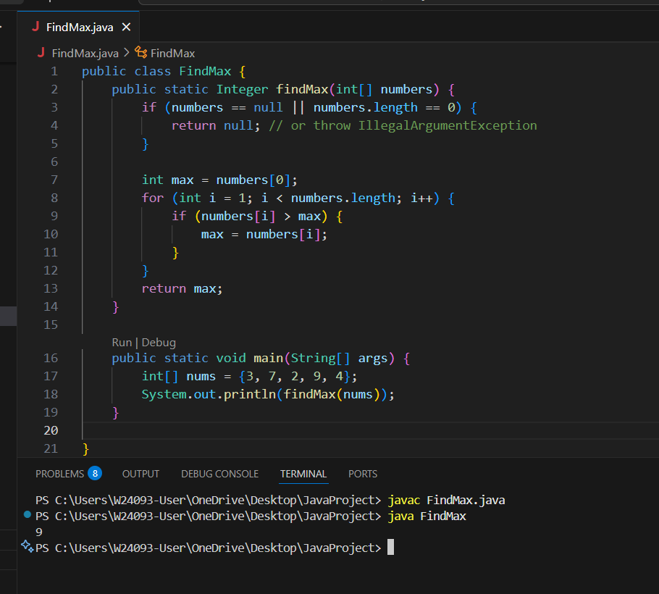

A: Negative numbers are handled fine; max can be negative.

B: Starting from index 1 is correct because numbers[0] is already assigned to max.

C: If numbers is empty, numbers[0] throws.ArrayIndexOutOfBoundsException.

D: The current method is O(n) and more efficient than sorting.

Q4.
Answer is B.

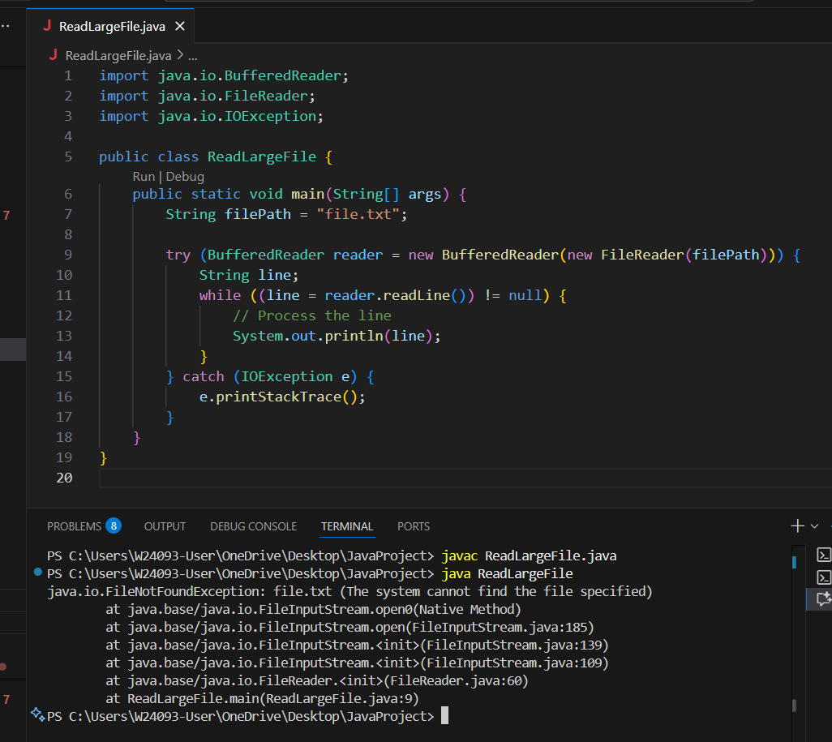

A: Works, but not safe if exception happens.

B: Correct.

C: Scanner works but slower than BufferedReader for large files.

D: Reads entire file into memory → may cause OutOfMemoryError for large files.

Q5.
Answer is B.

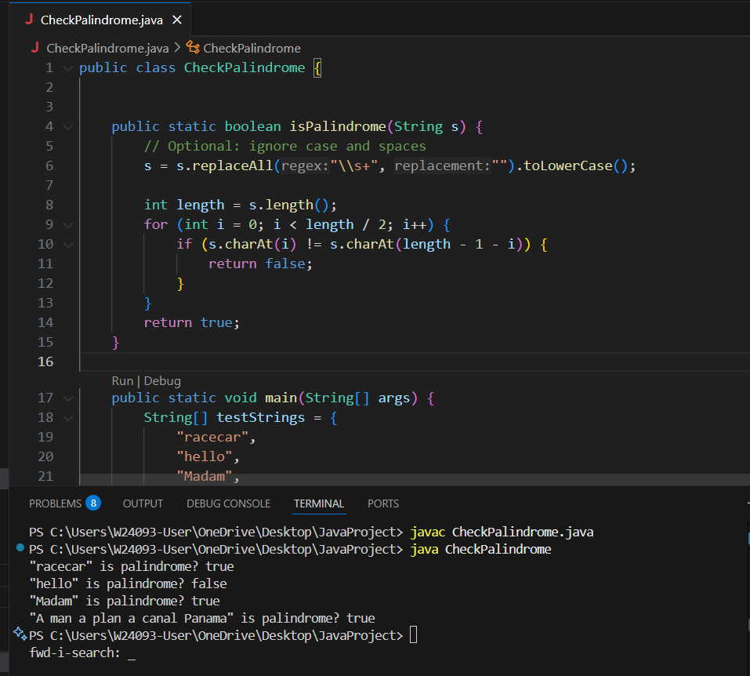

A: Work correctly, but not the most memory-efficient because of extra string creation.

B: Correct and efficient.

C: Work correctly but slower than B.

D: Not suitable for palindrome check.

Q6.
Answer is

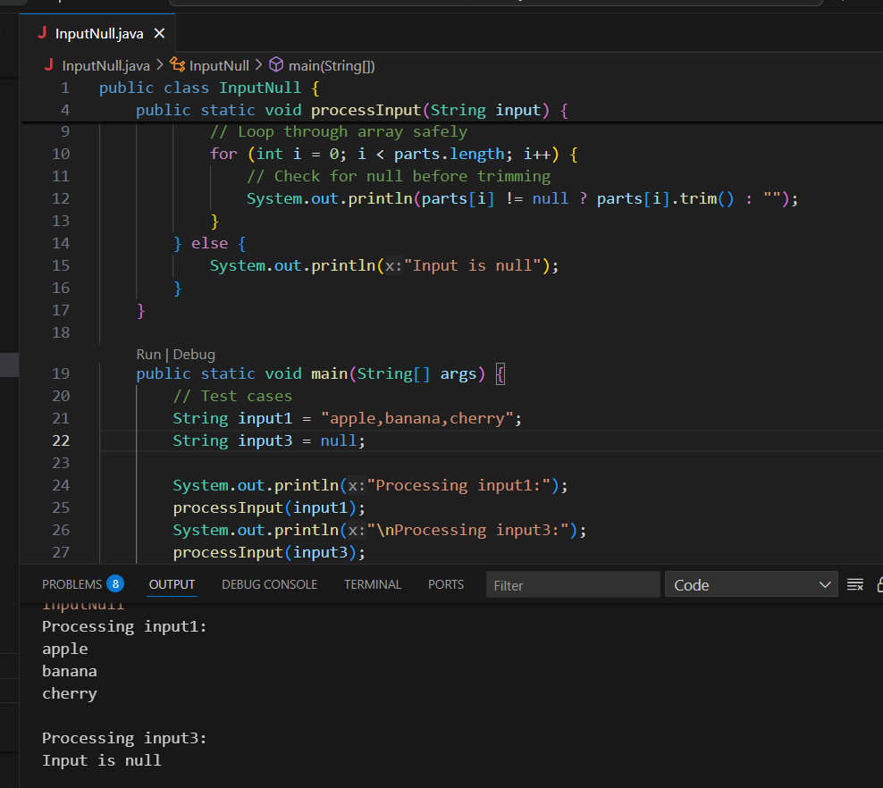

A: Stops ArrayIndexOutOfBoundsException. Last index is parts.length - 1.

B: Useful if input has trailing commas ("a,b," → includes empty string). Avoids losing last empty element.

C: Checks null input before calling split().

D: Ensures NPE does not occur if parts[i] is null.

Q7.
Answer is D.

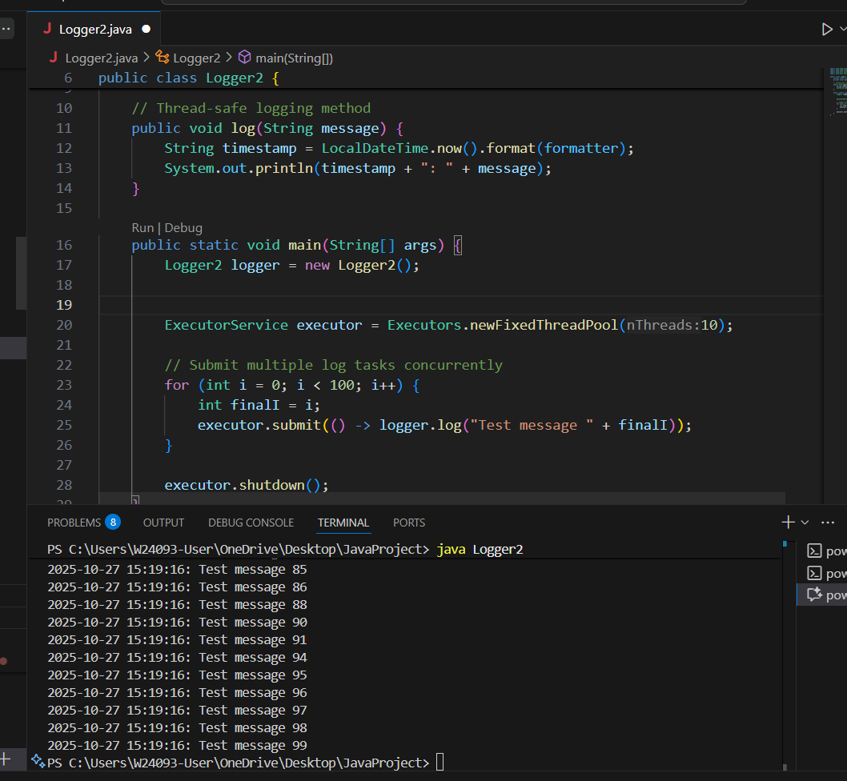

SimpleDateFormat maintains internal state when formatting dates.
Concurrent access can cause incorrect timestamps, exceptions, or corrupted output.
Creating a single shared instance in a multi-threaded environment is unsafe.

Q8.
Answer is

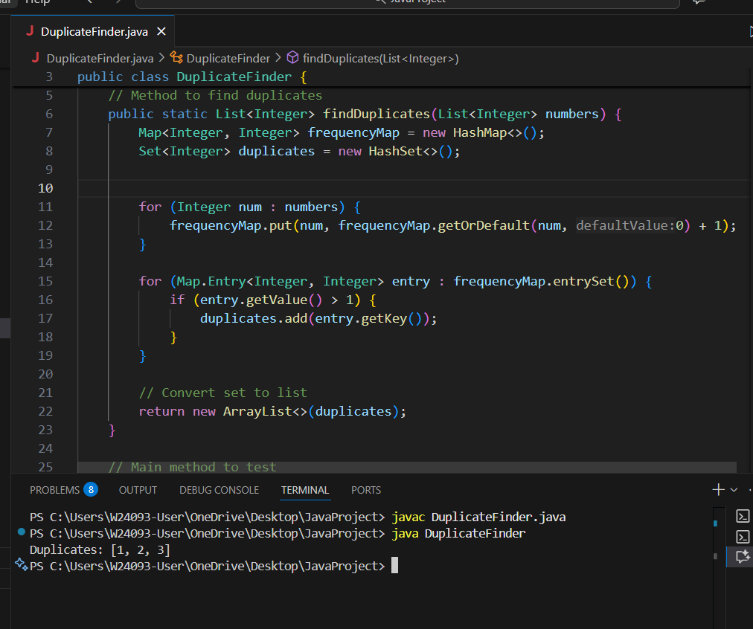

A: Correct. Avoids adding the same duplicate multiple times. Simple improvement.

B: Wrong. Would compare elements with themselves repeatedly, unnecessary work.

C: Work but inefficient. Collections.frequency iterates the list each time → O(n²) again.

D: Work. Returns unique duplicates. Similar complexity to C, but more readable.

